***Gergo Nagy - Implementation and Testing Unit (SQA PDA: Software Development)***

I.T 1 Encapsulation in a program

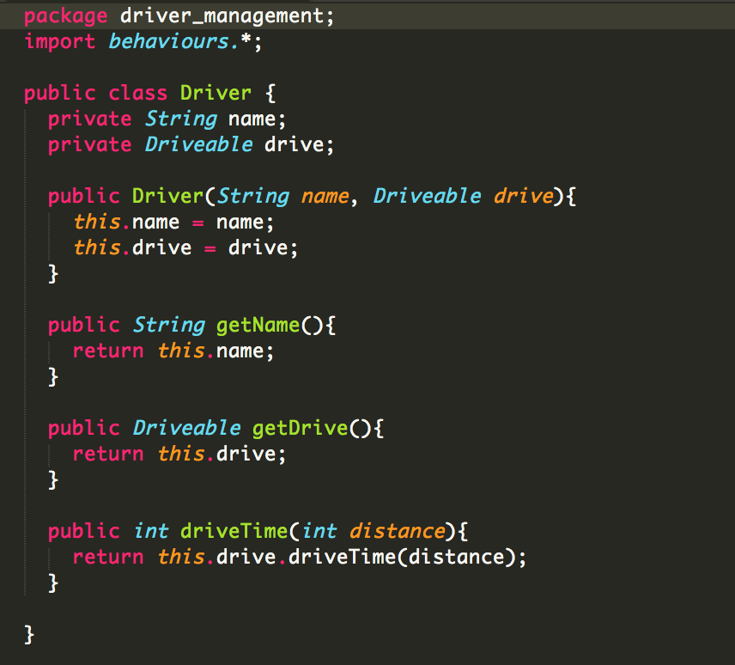

I.T 2 Inheritance in a program

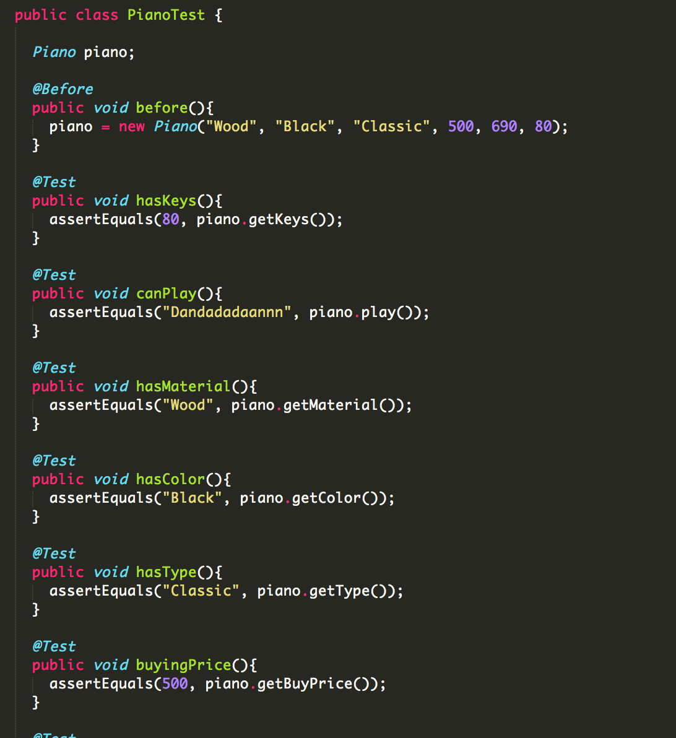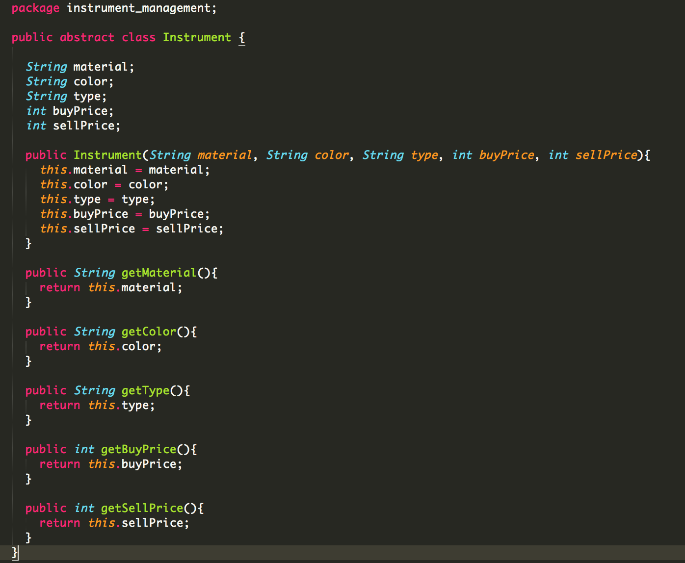

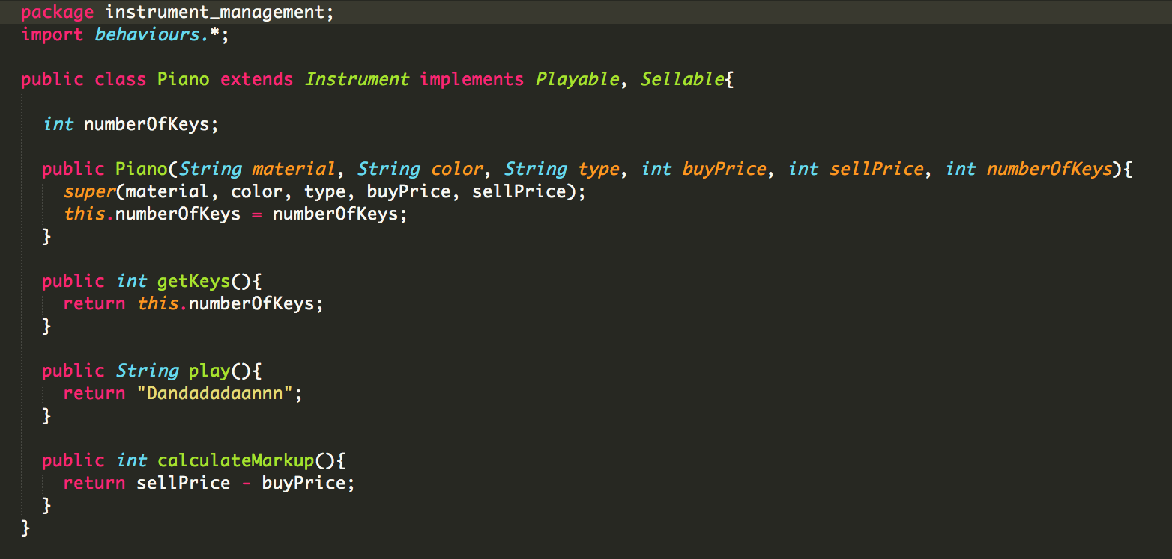

I.T 3 Demonstrate searching data in a program:

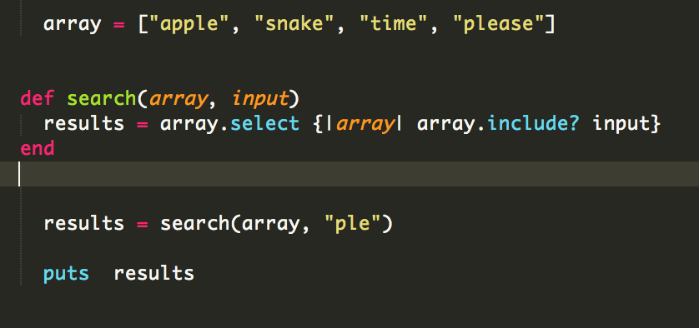

Result:

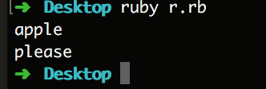

I.T 4 Demonstrate sorting data in a program:

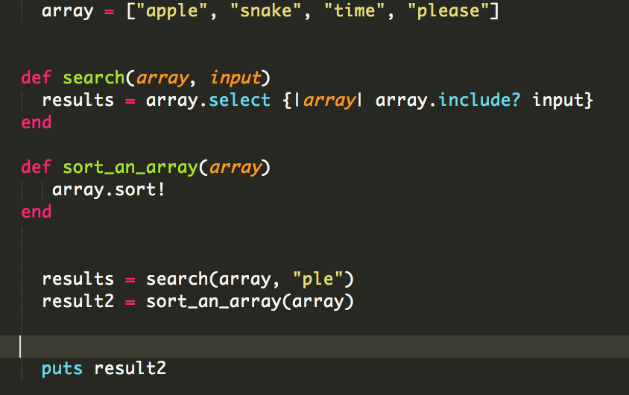

Result:

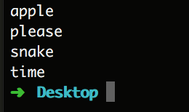

I.T 5 An array in a program:

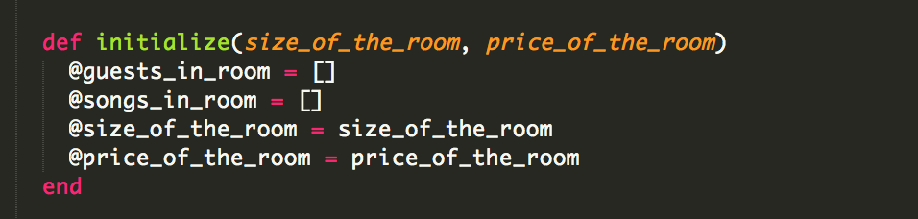

A function that uses the array:

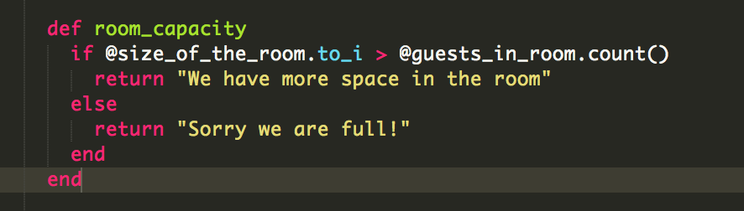

The result of the function:

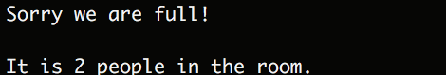

I.T 6

Add data to the new Hash, display count, delete a key and value:

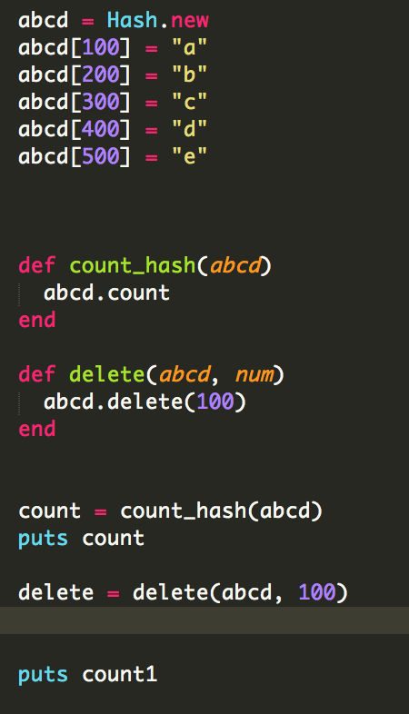

Display the result:

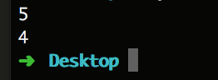

I.T 7 Demonstrate the use of Polymorphism in a program:

